NATALIA GROSSO

Argentina / Italian
Mobile Phone: +54 9 11 5157 5511 (Argentina)
E-mail: nataliacota@gmail.com

Born in Buenos Aires, Argentina - March 3rd 1976. Since 1998 Art director and Production Designer in commercials, feature films, short films, TV and photo production. Worked in several projects for the United States, Canada, Mexico, & Europe.
Lived and studied in New York City for 2 years (2009 – 2011)

Directors:
Armando Bo, Pucho Mentasti, Nacho Gayan, Baby, Diego Kaplan, Nicolai Fuglsig, Michael Karbelnicoff, Pep Bosch, Happy, Melodie McDaniel, Andrew Douglas , Who?, Jonas Anby , Jonas Akerlund, Laszlo Kadar, Simon Green, Edouard Deluc , Johnny Green, Lynn Fox, Daniel Burman, WAFLA, Hector Babenco, Juan José Campanella, Daniel Wolfe, Ian Pons Jewell

TV Commercials:
Coca-Cola, Bacardi, Heineken, Budweiser , Big Red , Telefonica , Visa, JCPENNEY, Sony Eriksson, LG, Hugo Boss, Old Spice, Gillette, Skoda, AT&T, Rexona, Motorola, Microsoft, Sony xperia, Smart, Samsung, Nintendo, Toyota, Powerade, etc.

Productions designers
Pierre Duboisberranger, Patrice Vermette, Ron Hellman, Anne Ross, Emma Fairley.

Features Films:
“El Mismo Amor, La Misma Lluvia”, “Valentín”, “Los Guantes Mágicos”, “El Abrazo
Partido”, “Imposible”, “El Pasado”.

- HIGH SCHOOL STUDIES:
- 1995 – Graduated from Colegio Julio Argentino Roca

- UNIVERSITY STUDIES:
- 1994 - 1998 – Major in Film Directing – Universidad de Buenos Aires.
- 2000 - Sketching – SVA (School of Visual Arts) - New York
- 2009 - Interior Space Planning – Parsons – New York
- 2010 - Drawing Course – SVA – New York
- Currently studying Architecture – UBA

- LANGUAGE STUDIES:
- ENGLISH: speaking, reading comprehension and writing.

- WORKING EXPERIENCE

2024

 | DIRECTOR | LOCAL PRODUCTION COMPANY | PRODUCTION COMPANY | PROJECT
PRODUCTION DESIGNER | Joaquin Guirales | Argentina Cine |  | YPF
PRODUCTION DESIGNER | Diego Contreras | 24/7 | Blur | Renault
PRODUCTION DESIGNER | Patrick Fileti | Good Gate | Green Point Pictures | Rexulti

2023

 | DIRECTOR | LOCAL PRODUCTION COMPANY | PRODUCTION COMPANY | PROJECT
PRODUCTION DESIGNER | Fridman Sisters | Argentina Cine | Stink | Michelob
PRODUCTION DESIGNER | Nono & Rodrigo | LABHOUSE | Partizian | Citizens
PRODUCTION DESIGNER | Santi Franco | Mama Hungara |  | BGH
PRODUCTION DESIGNER | Camila Zapiola | Argentina Cine | Stink | Doordash
PRODUCTION DESIGNER | Gustavo Taretto | Primo |  | Fargo
PRODUCTION DESIGNER | Santi franco | Mama Hungara |  | Patitas
PRODUCTION DESIGNER | Gustavo Taretto | Primo |  | Naranja X
PRODUCTION DESIGNER | Olivier Gondry | Huinca |  | Glade
PRODUCTION DESIGNER | Salamao Figueiredo | Huinca |  | Ziploc
PRODUCTION DESIGNER | Alexander Mavor | 24/7 | Soft Citizen | TD-insurance
PRODUCTION DESIGNER | Rudi Schwab | GoodGate | Eleanor | Elahere
PRODUCTION DESIGNER | The vortex | 20/20 | Chromista | Goody’s
PRODUCTION DESIGNER | Reynald Gresset | Labhouse | Agosto | Volvic

2022

 | DIRECTOR | LOCAL PRODUCTION COMPANY | PRODUCTION COMPANY | PROJECT
PRODUCTION DESIGNER | The Block | Huinca |  | Glade
PRODUCTION DESIGNER | Marcelo Burgos | 2020 films |  | Fernet Branca
PRODUCTION DESIGNER | Salamao Figueiredo | Huina |  | Ziploc
PRODUCTION DESIGNER | Sebastian Schor | 1st avenue |  | WhatsApp polls
PRODUCTION DESIGNER | Juan Frontini | Oruga |  | Unicenter
PRODUCTION DESIGNER | Santiago Franco | Mama Hungara |  | Galicia
PRODUCTION DESIGNER | Ignacio del Campo | Huinca |  | Levite
PRODUCTION DESIGNER | Luisa Kratch | Labhouse |  | Carrefour
PRODUCTION DESIGNER | Martin Levi | Oruga Films |  | Uala
PRODUCTION DESIGNER | Patrik von Krusenstjer TRAKTOR | Labhouse | Stink | sixt
PRODUCTION DESIGNER | Martin Holzman | Argentina Cine |  | Nutrilon
PRODUCTION DESIGNER | Jordan Bahat | Jacaranda | Golden LA | Ubrelvy
PRODUCTION DESIGNER | Alejandro Rey | Argentina Cine |  | Galicia
PRODUCTION DESIGNER | Matt Dilmore | Huinca | Caviar | STEM
PRODUCTION DESIGNER | Martin Levi | Oruga Films |  | Flow Lollapaloza

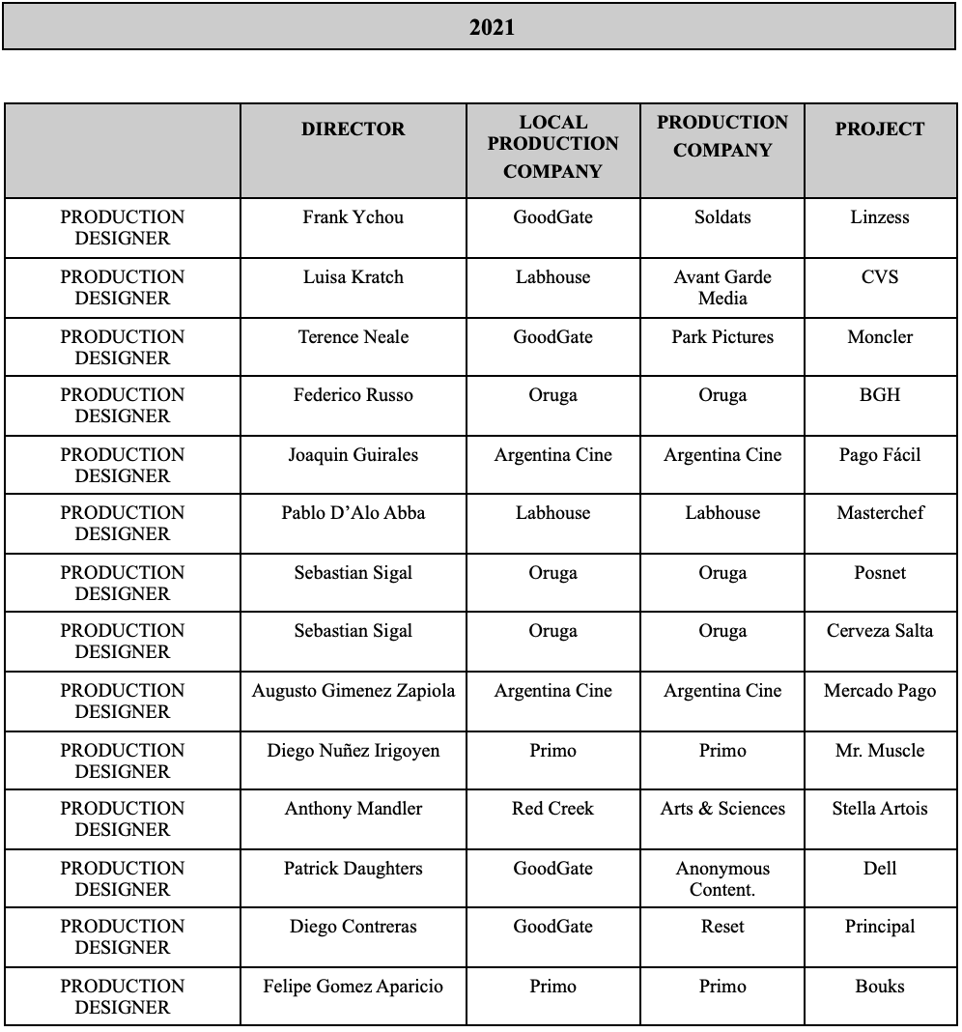

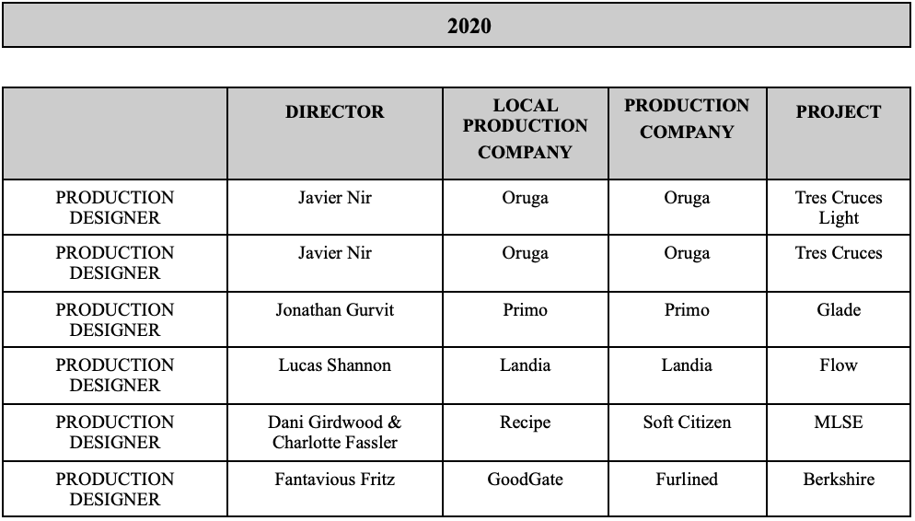

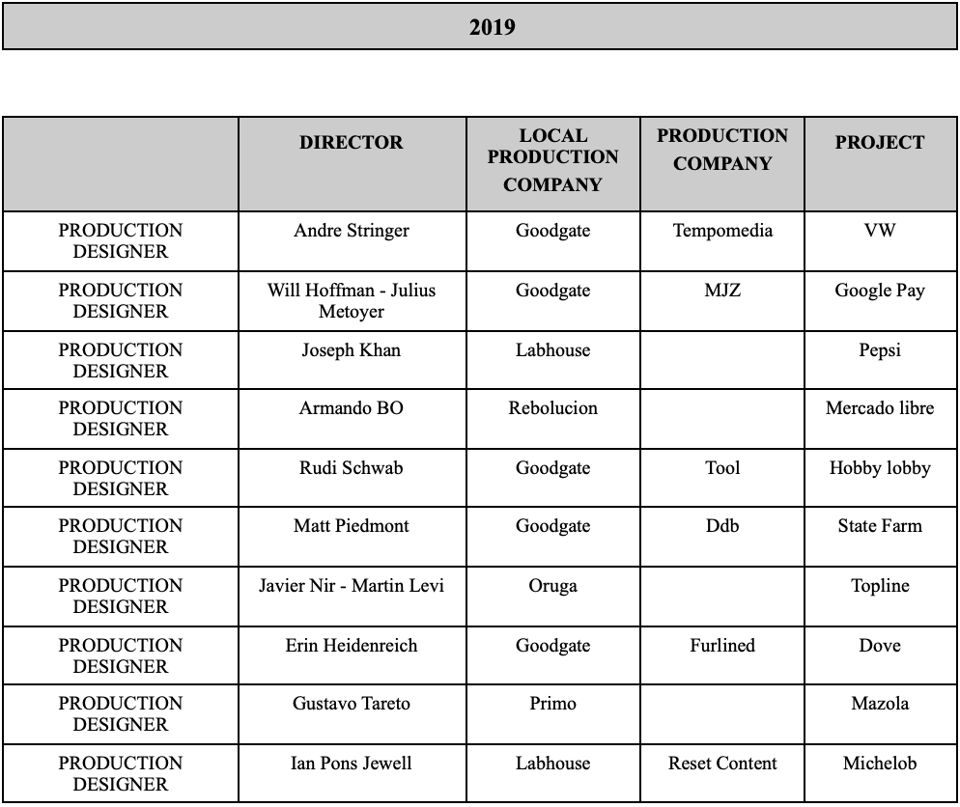

2018

 | DIRECTOR | LOCAL PRODUCTION COMPANY | PRODUCTION COMPANY | PROJECT
PRODUCTION DESIGNER | Nano | Labhouse |  | BAprovincia
PRODUCTION DESIGNER | Nano | Labhouse |  | Santander Río
PRODUCTION DESIGNER | Henry Meziat | Argentina Cine |  | Fernet Branca
PRODUCTION DESIGNER | Nicolai Fuglsig | Miggel & Sun | MJZ | Sky Mobile
PRODUCTION DESIGNER | Henry Meziat | Argentina Cine |  | Mercado Libre
PRODUCTION DESIGNER | Daniel Wolfe | Good Gate Arg. | Somesuch | Powerade

2017

 | DIRECTOR | LOCAL PRODUCTION COMPANY | PRODUCTION COMPANY | PROJECT
PRODUCTION DESIGNER | Georgi Banks | Good Gate Chile | Skunk | Toyota
PRODUCTION DESIGNER | Vladimir Duran | Argentina Cine |  | Gancia
PRODUCTION DESIGNER | Javier Duvit | Labhouse |  | Disney Chanel
PRODUCTION DESIGNER | Nano | Labhouse |  | Banco Provincia
PRODUCTION DESIGNER |  | Red Creek |  | Nisshinbo
PRODUCTION DESIGNER | Vania Haymann | Good Gate chile | Iconoclast | Sumsung S8
PRODUCTION DESIGNER | Jaime Rafn | Good Gate chile | Smuggler | Oppenheimer
PRODUCTION DESIGNER | Christina Hodnet | Good Gate chile | Blacklist | Snuggle
PRODUCTION DESIGNER | WAFLA | Primo | Iconoclast | Shock Top beer

2016

 | DIRECTOR | LOCAL PRODUCTION COMPANY | PRODUCTION COMPANY | PROJECT
PRODUCTION DESIGNER | Juanito | Genomma Lab. |  | Cicatricure
PRODUCTION DESIGNER | Ash Bolland | Labhouse | Interrogate | Nintendo
PRODUCTION DESIGNER | Javier Devitt | Labhouse |  | Quilmes
PRODUCTION DESIGNER | Johnny Green | Labhouse | Reset Content | Grey Goose
PRODUCTION DESIGNER | Juanito | Genomma Lab |  | Bagovit
PRODUCTION DESIGNER | Ariel Winograd | Winona |  | GCBA
PRODUCTION DESIGNER | Juanito | Genomma Lab |  | Cicatricure
PRODUCTION DESIGNER | Ariel Winograd | Genomma Lab |  | Triatop
PRODUCTION DESIGNER | Jonathan Agustavo | Good Gate Chile | SKUNK | Taco Bell
PRODUCTION DESIGNER | Franco Verdoia | Genoma |  | Unesia

2015

 | DIRECTOR | LOCAL PRODUCTION COMPANY | PRODUCTION COMPANY | PROJECT
PRODUCTION DESIGNER | Martín Hodara | Album |  | Irsa
PRODUCTION DESIGNER | Matt Aselton | Argentina cine | Big Fish | Smart
PRODUCTION DESIGNER | Franco Verdoia | Genoma |  | Triatop
PRODUCTION DESIGNER | Milton Kramer | Landia |  | Chandon
PRODUCTION DESIGNER | Martin Hodara | Album films |  | GlobaL CITIZEN
PRODUCTION DESIGNER | Martin Hodara | Album films |  | H&S
ART DIRECTOR | Jonas Akerlund | Rebolución | Serial Pictures | Vga
PRODUCTION DESIGNER | Camilo Antolini | 100 Bares |  | Pura Quinmica
PRODUCTION DESIGNER | Luis Cerveró | Labhouse | Blink | Skip
PRODUCTION DESIGNER | Patrick Giardino | Red Creek | Belive Media | Neutrogena
PRODUCTION DESIGNER | Jonathan Agustavo | Labhouse | Skunk | Taco Bell

2012 (Maternity Leave) 2013 -2014

 | DIRECTOR | LOCAL PRODUCTION COMPANY | PRODUCTION COMPANY | PROJECT
ART DIRECTOR | Alison MacLean | Labhouse | Park Pictures | ZyrtecD-part2
PRODUCTION DESIGNER | Mikon Van Gastel | Rebolución | Sibling Rivalry | Rexona
PRODUCTION DESIGNER | Watta Fernandez | La dobleA |  | Tang
PRODUCTION DESIGNER | Joao Nuno Pinto | Metrópolis | Garage films | Nos
ART DIRECTOR | Peter Thwaites | Labhouse | Gorgeus | A T&T
PRODUCTION DESIGNER | Matt Dilmore | Labhouse | Biscuit Filmworks | Capri Sun
ART DIRECTOR | Alison MacLean | Labhouse | Park Pictures | ZyrtecD
PRODUCTION DESIGNER | Matt Bieler | Rebolución | Serial Pictures | Rexona

2011 (Lives in NYC)

 | DIRECTOR | LOCAL PRODUCTION COMPANY | PRODUCTION COMPANY | PROJECT
PRODUCTION DESIGNER | Benjamin Quinn | LabHouse | The Sweet Shop | Kotex
PRODUCTION DESIGNER | Claudia Alberdi | Good Gate | - | Tylenol
PRODUCTION DESIGNER | Josh Miller | Good Gate |  | PaperMate
PRODUCTION DESIGNER | Luciano Urbani | Rebolución | Rebolución | Awafrut
PRODUCTION DESIGNER | Jonathan Gurvit | Primo BA | Primo BA | Play Station
PRODUCTION DESIGNER | Christian Bevilacqua | Rebolución | Radical Media | McDonalds
PRODUCTION DESIGNER | Diego Nuñez - Vladymir | Peluca Films |  | Santander Copa América
ART DIRECTOR | Randy Krallman | Good Gate | Smuggler | Motorola Xoom

2010 (Lives in NYC)

 | DIRECTOR | LOCAL PRODUCTION COMPANY | PRODUCTION COMPANY | PROJECT
PRODUCTION DESIGNER | Pete Candeland | Pioneras Producciones | Passion Pictures | Cappy
PRODUCTION DESIGNER | Marcelo Szechtman | Exterior Día |  | Cablevisión
PRODUCTION DESIGNER | Roy Ricci | Nunchaku |  | Pony Malta
PRODUCTION DESIGNER | Tony Barry | Pioneras Producciones | Academy Films | Persil

2009 (Lives in NYC)

 | DIRECTOR | LOCAL PRODUCTION COMPANY | PRODUCTION COMPANY | PROJECT
Stand designer |  |  | Sibilia | Stand for jewelry (New York)
PRODUCTION DESIGNER | Russel Brooke | Good Gate | Passion Picture | Evergreen
PRODUCTION DESIGNER | Karina Minujin | Landia | - | Raid
ART DIRECTOR | Otto Alexander | Good Gate | Bigfish | Obi

2008

 | DIRECTOR | LOCAL PRODUCTION COMPANY | PRODUCTION COMPANY | PROJECT
PRODUCTION DESIGNER | Pucho Mentasti | Blue | - | TyC Sports
PRODUCTION DESIGNER | Edouard Deluc | Campo cine | - | VOYAGES VOYAGES  Short Movie
PRODUCTION DESIGNER | Joey Garfield | Pioneer | Academy Films | Visa
ART DIRECTOR | Matthijs Van Heijnengen | Good Gate | soixan7e quin5e | Pepsi
PRODUCTION DESIGNER | Santiago Elias | Ursula |  | New Age
PRODUCTION DESIGNER | Fran Torres | Republicana | Indio Films | JCPenny
PRODUCTION DESIGNER |  | Pioneer |  | Microsoft
PRODUCTION DESIGNER | Jonas Anby | Good Gate |  | Doritos
PRODUCTION DESIGNER | Lynn Fox | Pioneer | Blink Productions ldt. | Sony Eriksson
PRODUCTION DESIGNER | Derin Seale | Rebolución | Radical Media | LG
ART DIRECTOR | Nacho Gayan | Pioneer | Smuggler | Cola Diet
PRODUCTION DESIGNER | Mark Claywell | Pioneer |  | Grant Thorton
PRODUCTION DESIGNER | Doble Nelson | Rebolución | Lee films | Aquarius
PRODUCTION DESIGNER | Baby | Rebolución | - | Ariel
PRODUCTION DESIGNER | Emil Moller | Pioneer | Sonny - Ph | Hugo Boss
PRODUCTION DESIGNER | Gregor Nicholas | Rebolución | Radical Media | The Ladders
PRODUCTION DESIGNER | Bernd Seibold | Good Gate | C.3 | Skoda

2007

 | DIRECTOR | LOCAL PRODUCTION COMPANY | PRODUCTION COMPANY | PROJECT
PRODUCTION DESIGNER | Ricardo Paoletti | Pioneer | Casta DIva | AZ Dent
PRODUCTION DESIGNER | Karina Minujin & Maxi Blanco | Landia | - | Toyota
PRODUCTION DESIGNER | Melanie Bridge | Pioneer | The sweet shop | National Bank
PRODUCTION DESIGNER | Simon Green | Film Planet | H.S.I London | Fixodent
PRODUCTION DESIGNER | Edouard Deluc | Good Gate | Lestélécréateurs | Decathlon
PRODUCTION DESIGNER |  | Pioneer |  | Re/Max
ART DIRECTOR | Melodie McDaniel | Good Gate | The directors Bureau | Betty Crocker
PRODUCTION DESIGNER | Camilo Antolini | 100 Bares | - | TCM
PRODUCTION DESIGNER | Gabrielle Simson & Andrew Becker | Pioneer | Radical Media | Nexium
PRODUCTION DESIGNER | Simon Green | Altana | H.S.I London | Shell
PRODUCTION DESIGNER | Bernd Seibold | Good Gate | C.3 | Skoda
PRODUCTION DESIGNER | Daniel Harder | Good Gate | Trigger Happy | Tom Tailor

2006

 | DIRECTOR | LOCAL PRODUCTION COMPANY | PRODUCTION COMPANY | PROJECT
PRODUCTION DESIGNER | Laszlo Kadar | Good Gate | Lazslo Kadar | Wagner
PRODUCTION DESIGNER | Jonas Anby | Good Gate | Depofilms | Ruffles
SET DRESSER | Hector Babenco | K&S Films | - | Film  El Pasado
PRODUCTION DESIGNER | Bruce Huwit | Altana Films | Crossroads | Pampers
ART DIRECTOR | David Frankham | Altana Films | Smuggler | Talk Talk
ART DIRECTOR | Steve Chase | Altana Films | - | Old Spice
PRODUCTION DESIGNER | Julia Jason | Altana Films | Crossroads | Pampers
PRODUCTION DESIGNER | Nicolas Bo | Rebolucion | - | Efectivo Si

2005

 | DIRECTOR | LOCAL PRODUCTION COMPANY | PRODUCTION COMPANY |  |  | PROJECT
PRODUCTION DESIGNER | Justin Klarenbeck | Altana Films | Space Program |  |  | Benadryl
PRODUCTION DESIGNER | Who? | Altana Films | Go Films & Great Guns |  |  | Ricoh
SET DRESSER | Armando Bo | Rebolucion | - |  |  | Visa
PRODUCTION DESIGNER | Mariano Lemon | Rebolucion | - |  |  | Cartoon Network
SET DRESSER | Javier Nir  Pablo Fisherman | Oruga Films | - |  |  | Sedal
PRODUCTION DESIGNER | Baby | Rebolucion | - |  |  | Coca cola
SET DRESSER | Lawrence Jacomelli | Altana Films | Great Guns |  |  | Persil
SET DRESSER | Andrew Douglas | Altana Films |  |  |  | Panasonic
ART DIRECTOR | Michael Karbelnicoff | Altana Films | HKM |  |  | Gillette
SET DRESSER | Greg Maya | Altana Films |  |  |  | Clairol
ART DIRECTOR | Stacy Wall | Altana Films |  |  |  | Holliday inn
ART DIRECTOR | Paulo Vainer | Altana Films | Zohar cinema |  |  | Gillett
2004
 | DIRECTOR | LOCAL PRODUCTION COMPANY | PRODUCTION COMPANY |  | PROJECT
SET DRESSER | Nicolai Fuglsig | Altana Films | MJZ LA |  | Big Red
SET DRESSER | Melodie McDaniel | Altana Films | The directors Bureau |  | Vodafone Global
ART ASSISTANT | Photographer | - | - |  | Saks
SET DRESSER | Happy | Pionner | - |  | Bacardi
SET DRESSER | Pep Bosch | Altana Films | Rock Fight |  | Kleenex
SET DRESSER | Rocky Morton | Altana Films | MJZ LA |  | Smirnoff
SET DRESSER | Michael Karbelnicoff | Altana Films | HKM |  | Gillette
2003
 | DIRECTOR | LOCAL PRODUCTION COMPANY | PRODUCTION COMPANY |  | PROJECT
SET DRESSER | Nicolai Fuglsig | Altana Films | MJZ UK |  | Carrefour
SET DRESSER |  | Altana Films |  |  | Labbat bleue
ART DIRECTOR | Norman Christianson | Altana Films | Cuatro y Medio |  | Bacardi
SET DRESSER | Daniel Bohm | Bohm Cine | - |  | Sedal
SET DRESSER | Paulo Vainer | Altana Films | Zohar Films |  | Gillett
SET DRESSER | Luciano Halac | Pol - KA | - |  | La Casa
ART ASSISTANT | Daniel Burman | BD Cine | - |  | Film - El Abrazo Partido
SET DRESSER | Diego Kaplan | Wasabi | - |  | Skip
SET DRESSER | Daniel Bohm | Bohm Cine | - |  | Suave
SET DRESSER | Fernando Vallejo | Trip Film | Trip Film |  | Banco Puerto Rico
SET DRESSER | Luciano Quilicci Roberto Bonomo | Landia | - |  | Colgate
2002 - 1998
 | DIRECTOR | LOCAL PRODUCTION COMPANY | PRODUCTION COMPANY |  | PROJECT
SET DRESSER | Fernando Vallejo | Spaghetti | - |  | Bacardi
SET DRESSER | Fernando Vallejo | Spaghetti | - |  | Budweiser
WORDROBE ASSIST. | Martin Rejtman | Rizoma | - |  | Film  Los guantes magicos
ART ASSIST. | Cristian Pauls | Axel Pauls | - |  | Film  Imposible
SET DRESSER | Alfredo Stuart | SCP | - |  | Coca Cola
ART ASSIST. | Alejandro Agresti | Patagonik | - |  | Film  Valentin
PRODUCTION ASSIST. | Juan Jose Campanella | Jorge Estrada Mora | - |  | Film  El Mismo Amor La misma Lluvia

